March 2022 |  |  |  |  |  | Issue 1
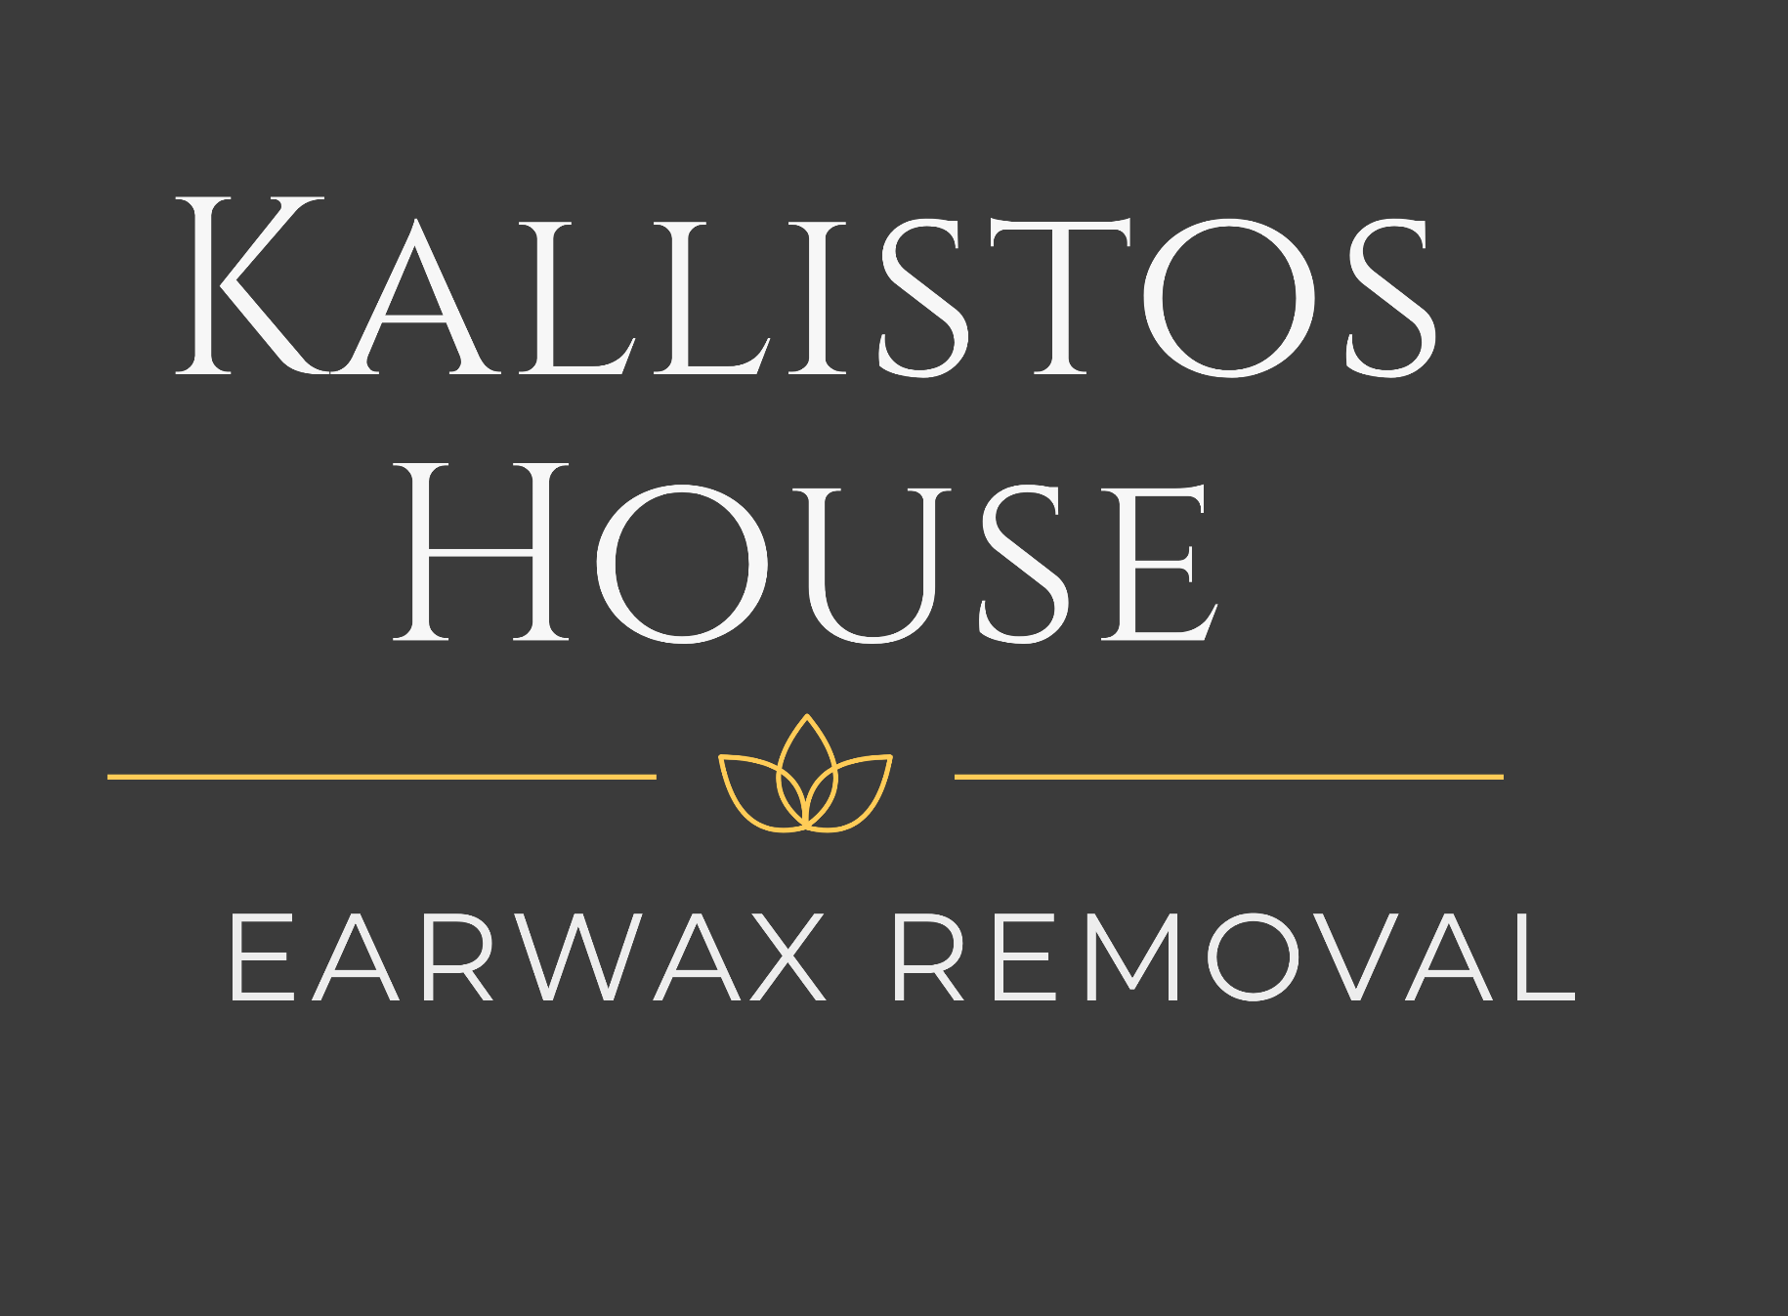
You may not be able to see us but we are here and we do promise to protext your data by using a recognised and secure websit like Wix.com
Website Terms and Conditions
As agreed by website owners. Updated March 2022
  Annette Hall-Tuitt  Director | In order to use Kallistos House services you must be over 18 years of age, booking services for anyone under 18 is prohibited by UK law. Our service users must be of the legal age of majority in the UK, and possess the legal authority, right and freedom to enter into these Terms as a binding agreement in accordance with UK laws. It is not the policy of this company to accept deposits or payment for services using our website. Cash or card payments are received face to face, which allows us to verify age of each client. |  |  | Website Owner: This website is owned and operated by Kallistos House which is the trade name for H & T healthcare and consultancy ltd. These Terms give the terms and conditions under which you may use our website and services as offered by us. This website offers visitors an opportunity to read about the services offered like ear wax removal and Aesthetics. It also offers you a booking service. Note we do not accept payments online. By accessing or using the website to book services, you approve that you have read, understood, and agree to be bound by these Terms.
The Service and all materials there in or transferred thereby, including, without limitation, software, images, text, graphics, logos, patents, trademarks, service marks, copyrights, photographs, audio, videos, music and all Intellectual Property Rights related thereto, are the exclusive property of H & T health care and consultancy Ltd. Except as explicitly provided herein, nothing in these Terms shall be deemed to create a license in or under any such Intellectual Property Rights, and you agree not to sell, license, rent, modify, distribute, copy, reproduce, transmit, publicly display, publicly perform, publish, adapt, edit or create derivative works thereof. All content on this site has been applied with consent from clients for use in promotion of the service.  The logos, trade mark, videos and pictures we have on the site are licensed to H&T healthcare and consultancy Ltd  Right to change and modify terms  We reserve the right to modify these terms from time to time at our sole discretion. Therefore, you should review these page periodically. When we change the Terms in a material manner, we will notify you that material changes have been made to the Terms. Your continued use of the Website or our service after any such change constitutes your acceptance of the new Terms. If you do not agree to any of these terms or any future version of the Terms, do not use or access (or continue to access) the website or the service.  Retention of right to change offers.  We may, without prior notice, change the services; stop providing the services or any features of the services we offer; or create limits for the services. We may permanently or temporarily terminate or suspend our services without notice and liability for any reason, or for no reason.  The prices we charge for using our services are listed on the website, we reserve the right to change our prices for services displayed at any time, and to correct pricing errors that may inadvertently occur. Additional information about pricing is available on the service pages. We do not charge VAT.  Preference of law and dispute resolution  These Terms, the rights and remedies provided hereunder, and any and all claims and disputes related hereto and/or to the services, shall be governed by, construed under and enforced in all respects solely and exclusively in accordance with the internal substantive laws of the United Kingdom, without respect to its conflict of laws principles. All such claims and disputes shall be brought in, and you hereby consent to them being decided exclusively by a court of competent jurisdiction located in the United Kingdom. The application of the United Nations Convention of Contracts for the International Sale of Goods is hereby expressly excluded. |  |  |  | We do not ship or sell Goods from this web site. We do not offer subscriptions or memberships. We do not take deposits over the phone or on our website. Persons with sudden hearing loss should be seen by a GP. Lastly our service does not see persons under 18 for Aesthetics, Cryotherapy or Earwax removal.  - Stephen Tuitt Director
Responsibilities for service provided.
When we receive a valid claim for dissatisfaction of service, we will offer to correct the damage and give support to the client in line with our duty of candor. However should the client wish to make a claim insurance details can be requested from customer service via email. The customer will also be entitled to a full refund.
Limitation of liability
To the maximum extent permitted by applicable law, in no event shall Kallistos House or its parent company, be liable for any indirect, punitive, incidental, special, consequential or exemplary damages, including without limitation, damages for loss of profits, goodwill, use, data or other intangible losses, arising out of or relating to the use of, or inability to use, the service.
To the maximum extent permitted by UK law, Kallistos house and its Parent company assumes no liability or responsibility for any (i) errors, mistakes, or inaccuracies of content; (ii) personal injury or property damage, of any nature whatsoever, resulting from your access to or use of our service; and (iii) any unauthorized access to or use of our secure servers and/or any and all personal information stored therein.

